Londeka Mpungose
St10531777
Wede5020
Poe
Part 3



Organization overview

organization | Luhlelo
industry | Water and sanitation
Category | Water services
Website published on | https://github.com.mpungoselondeka/st10531777

lUHLELO ORGANISATION
Description:
Water is a basic need, we need it in our everyday life, be it for drinking, hygiene, cooking, or agriculture, but in South Africa we have a water crisis. our people rely on water provided by the government through local municipalities, but they face water scarcity everyday and their problems take long to get attended to simply because of a lack of means to quickly communicate with their local municipality.

The Luhlelo organisation website has been designed to help communities reach municipalities faster by developing a real time sensor integration whereby the manual system will be bypassed and update the municipal dashboard immediately. We will also have Gis mapping to track all the infrastructure to help keep track and be able to fix them within a short space of time.

It is made for the people, we have a complaints page where you can lodge a complaint, it has a button where you select the type of issue you are facing, you can also rate its priority and submit photos of evidence.

reasons for choosing this organisation.
safe and clean water for everyone, we are helping people with one of their most basic needs while increasing their lifespan by improving their way of living. Our organisation intends to improve the water quality received by everyone which will help decrease the contracting of water borne diseases like cholera. Although it is mostly catering to the communities it is also of note that it will be also helping municipalities which helps the Government bring good service delivery to the citizens of the country. It’s safe and reliable and there are no costs required from the citizens.

Website goals and objectives:
- Our website is made to enhance transparency of the municipalities by providing the details of the project that they are doing.
- It’s designed to facilitate communication between the municipalities and communities.
- To help communities manage to hold the municipalities accountable we also have a complaints page reporting directly to water works department.
- We also plan to help provide water even in impoverished areas through projects that are funded and through donations that we get.

Current website analysis
Strengths of the existing website
- Contains basic contact information
- It includes online donation button
- It contains information on the impact our foundation has had on the communities.
- Has a functioning contact form for enquiries.

weaknesses and areas for improvement
- Poor mobile responsiveness, the website is not optimised for smartphone or tablets.
- Absence of a blog or content marketing section to drive organic traffic.
- No search engine optimisation (SEO) strategy in place.

Key performance indicators
Operational efficiency (through real time sensor reporting)
- Resolution time: The average time from report to repair
- Completion rate: The percentage of total reports successfully resolved
- Cost savings: Estimated money saved by catching leaks early
Community trust
- User adoption: Growth in the number of registered citizens over time
- Gis mapping: mapping where reports come from to ensure all neighbourhoods are being heard equally
Platform health
- Mobile usage: looking at the percentage of reports made via smartphones-vital for on-the-spot reporting
- Bounce rate- checking the difficulty of the form by looking at the percentage of people who leave the site without finishing a report.

Proposed website features and functionality
Core pages
- Home page- hero banner, key value propositions
- About us- organisation history, team profiles
- Donations page- online donation form, information on where the donations go to
- Impact page- information on completed projects done by the organisation, ongoing projects, and stats on the number of citizens helped
- Contact us- map integration, contact form, live chat
- Live reports- report on help

Key functionality
- Mobile first responsive design- fully optimised across all device types
- Seo optimisation- structured data, meta tags, site map and google analytics integration.
- Multi-currency display- ZAR as primary with USD/EUR conversion indicators
- WhatsApp special notification- no data WhatsApp enabling fast reporting

Design and end user experience
Design aesthetic and branding
The colours used in our website are intentional to build trust with our users and reassure that our services are dependable.
Design style | Fluid natural elements
Inspiration | Warm green tones, soft blue accents
Aesthetic | Clean, editorial layout.

Colour scheme

medium aquamarine | aquamarine | blue | Navy blue
Primary accent | background | Headings and texts | Supporting accent

Typography
primary heading font | Inter sans serif-for the organisations name, page titles and hero text
secondary heading font | Outfit sans-serif -clean but approachable for the subheadings
Body copy font | Open sans-serif highly readable for descriptions and content.
Font hierarchy | H1:48-64px H2:32-36px body:16px captions:13px

Technology stack
frontend | HTML5, CSS3, (with css variables & grid)
CSS framework | Tailwind CSS – for rapid, consistent utility-based styling
Version control | Git (GitHub)- for codebase management and collaboration.
analytics | Google analytics 4 + Google search console
accessibility | Axe dev tools and lighthouse audits

Luhlelo organisation milestones



Budget
Clients name: | Luhlelo organisation | Location: | South Africa
projects code: | Abje65977 | Start date: | 19/02/2026
Exchange rate: | 27.79 ZAR | End date: | 04/06/2028

Sr.no. | particulars | Est hrs | Rate/hr | amount | Total amount
1 | Designing page layout | 13 | R1000 | R13000
2 | Domain registration | 8 | R2303 | R18424
3 | About us page | 4 | R1010 | R4040
4 | Impact page content | 17 | R650 | R11050
5 | Donation page content | 13 | R455 | R5915
6 | Add text | 13 | R70 | R910
7 | Add text | 9 | R75 | R695
8 | Add text | 6 | R70 | R420
 |  |  |  |  | R54 874

Website assets

Our logo

Icons8



Volunteers conducting data in the community

pixabay

the jojo tank installed at niwe from our project
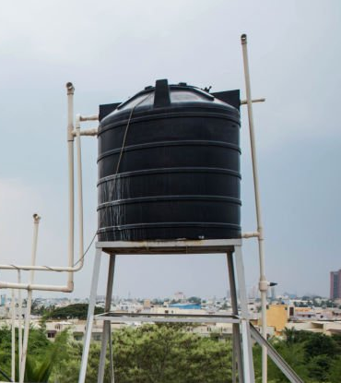

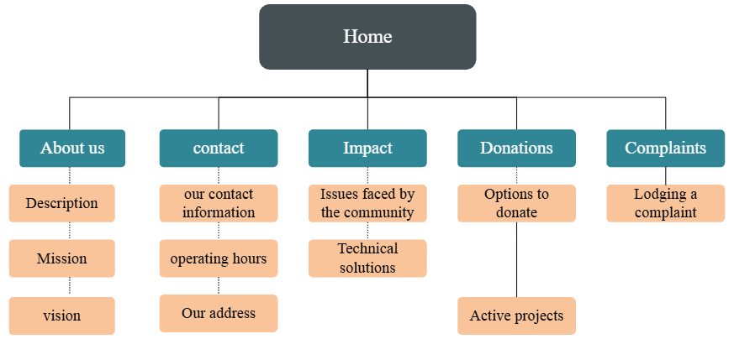

References:
Istockphoto.com. (2026). Available at: https://media.istockphoto.com/id/1392593112/photo/amazing-young-african-business-woman-standing-over-grey-wall.jpg?s=1024x1024&w=is&k=20&c=i2AHjYyxtVDWVGKJSl1S88yeBeGXSh6WyKni2dn9IeE= [Accessed 20 Apr. 2026].

‌Istockphoto.com. (2026). Available at: https://media.istockphoto.com/id/1743115949/photo/happy-woman-lawyer-and-mockup-space-in-career-ambition-or-vision-against-a-bokeh-background.jpg?s=1024x1024&w=is&k=20&c=-0nYN8z9LPhKsOoi7Lyi_J_n-JKd6gY6NggVqb70OP4= [Accessed 20 Apr. 2026].

‌Istockphoto.com. (2026). Available at: https://media.istockphoto.com/id/1148048210/photo/girl-and-friends-putting-some-clothes-for-donation-into-boxes.jpg?s=1024x1024&w=is&k=20&c=r7jo81Xf5bY6GuIE2N_YdUKVqovE5Iock9ULJS_ozSk= [Accessed 20 Apr. 2026].

‌Istockphoto.com. (2026). Available at: https://media.istockphoto.com/id/523996051/photo/water-tank.jpg?s=1024x1024&w=is&k=20&c=4IzzJsIevXQv99AQBExVmKWI1xtDa1Q4oE0deyX3r0Q= [Accessed 20 Apr. 2026].

